Levi George

02/14/2021

CS 350: Programming Language Design

Prof. Amal Khalifa

Homework 2: Grammars, Parse Trees, and Semantics

Q1.

1. Draw a parse tree for: (

1. Show the rightmost derivation for the statement in a.

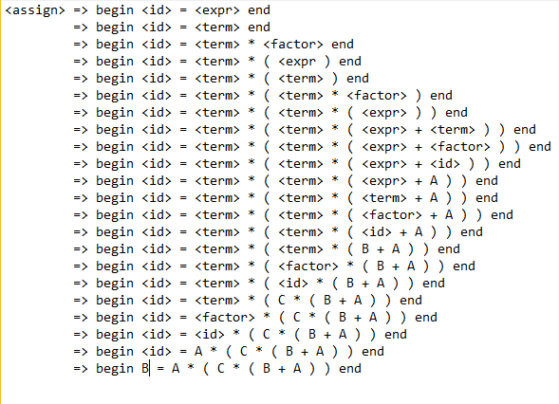

1. Rewrite the grammar to add the ++ and – operators

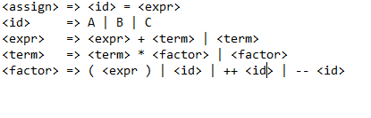

1. Rewrite the grammar in EBNF

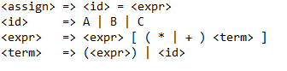

Q2. Consider the Ruby case Statement:

1. Describe the syntax in BNF (**I wasn’t sure how far you wanted me to go with the BNF definition, so I just went up to the assignment and identifier definition**)

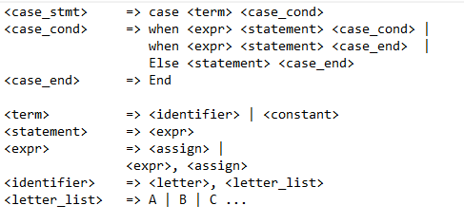

1. Using virtual machine instructions given below, give an operational semantic definition of the statement.

